TO MY UNKNOWN WHOLE FOODS FRIEND

Chatting with you on the Whole Foods checkout line two Fridays ago was lovely. Surprisingly, in just a few short minutes, we found a number of mutually-interesting connections. Israel: You’d lived there for a few years, and I’d been there often through my work as a Jewish communal professional. Columbia: You work at the Columbia University Press, while I have a doctorate in black literature from the university. Composting: You do it, and I, well, failed at it.

After a warm good-bye and best wishes for a “Shabbat Shalom,”, I left the market before you. Almost immediately, I regretted not waiting around to ask if you’d like to go for a cup of coffee. After all, we seemed to have begun a real conversation. The trouble was, and I didn’t want to have to admit it, I’d already forgotten your name. Yes, I dropped the ball.

So what should I do now to reconnect with you? My daughter Rachel asked the same question of upper westsiders on the NextDoor app. Many suggestions were offered, many of which suggested that I write something up – which is this – and somehow find a way to circulate it in [your] the CUP offices. It’s an intriguing idea, but I don’t know how I’m going to do it. I’ve called the offices several times, and the company’s voice message system sternly asserts that there’s a “no visitors” policy in place right now. But maybe there’s a technological way around the ban.

I hope I succeed and that this reaches you. If any of my recounting or the face in the image below sounds or looks familiar, and if you have any interest in following up, please be in touch. My email is [deleted] and my mobile is (917) 596-8500.

Finally, and I certainly don’t want to put any undue pressure on you, my daughter tells me that everyone on the UWS is rooting for me.

Your [soon to be contacted?] friend,

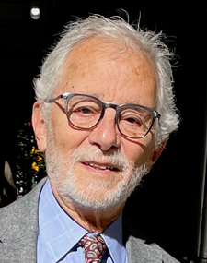

Larry Rubin

